**Batch: D - 1 Roll No.: 16010122096**

**Experiment / assignment / tutorial No. 07**

**Grade: AA / AB / BB / BC / CC / CD /DD**

**Signature of the Staff In-charge with date**

**Experiment No.:7**

|  |
| --- |
| **TITLE:** Building and configuring simple topology using Network tool - CISCO PACKET TRACER. |

**______________________________________________________________________________**

**AIM:** To build and configure VLAN (Virtual LAN) using CISCO Packet Tracer.

Packet Tracer is a network simulation program that allows students to experiment with network behaviour and ask “what if” questions. Packet Tracer provides simulation, visualization, and authoring, assessment, and collaboration capabilities and facilitates the teaching and learning of complex technology concepts.

**_____________________________________________________________________________**

**Expected Outcome of Experiment:**

**CO1:**  Explain the fundamentals of the data communication networks, reference models,

topologies, physical media, devices, simulators and identify their use in day-to-day networks.

**CO3:** Demonstrate various network layer protocols and network design using IP addressing

concepts.

**_______________________________________________________________**

**Books/ Journals/ Websites referred:**

1. <http://www.google.com>
2. A. S. Tanenbaum, “Computer Networks”, Pearson Education, Fourth Edition
3. B. A. Forouzan, “Data Communications and Networking”, TMH, Fourth Edition
4. [CISCO PACKET TRACER 6.0.1 and Higher version (free download)](https://mega.co.nz/#!q4p0wS7Z!J9jkMwXzZSO4zP1kZX632VFYyxNzwPUhvx8f8Ejyen0 (53.3 MB))

**Pre-Lab/ Prior Concepts: Virtual LAN**

A virtual local area network (VLAN) is a LAN which is not configured by physical wiring but it is configured by software. A VLAN is logical group of network devices that appear to be on same LAN despite their geographical distribution. A VLAN is implemented so that network administrators can connect a group of host in the same domain inspite of their physical location to achieve scalability and improve security features.

To subdivide a network into virtual LANs, one configures a network switch or router. Simpler network devices can partition only per physical port (if at all) , in which case each VLAN is connected with a dedicated network cable ( and VLAN connectivity is limited by the number of hardware ports available) More sophisticated devices can mark packets through tagging, so that a single interconnect ( trunk) may be used to transport data for multiple VLANs. VLAN can greatly simplify network design and deployment, because VLAN membership can be configured through software.

**______________________________________________________________________________**

**New Concepts to be learned**: Purpose of this lab is to become familiar with building Virtual Network in Packet Tracer. ______________________________________________________________________________

**Stepwise-Procedure:**

1. Creating a simple LAN network using packet tracer:

Step 1: Select 12 PCs from the end devices and one fast ethernet switch (2950/24 ports)

Step 2: Connect PCs and switch via copper cable from the panel. Connection can be verified by appearance of all green dots on the links.

Step 3: For PCs to communicate click on PC0.

* Dialog box for PC0 appears
* Click on desktop applications by packet tracer.
* Go to IP configuration.
* Enter IP address to identify host i.e. PC0 (for example: 192.168.1.1)
* Subnet mask-by default already set one can change it as per his/her specification.

Step 4: Repeat step 3 for PC1

Step 5: Ping the PCs and check their working status.

Step 6: Simple PDU (Protocol Data Unit) to simulate network traffic by sending ICMP PDU to assess the network traffic. View simulation in simulation mode

Step 7: . Configure two VLAN in a switch in 6 verticals.

Step 8. As per design, assign membership of VLAN to port using following command

# switch port access vlan2 or vlan3

Step 9. Check status of VLAN.

**IMPLEMENTATION:** (printout of simulation code)

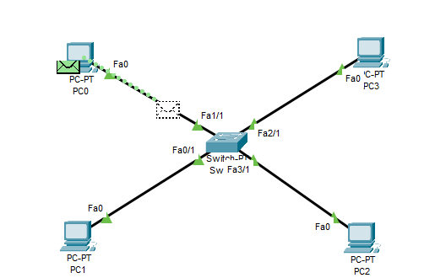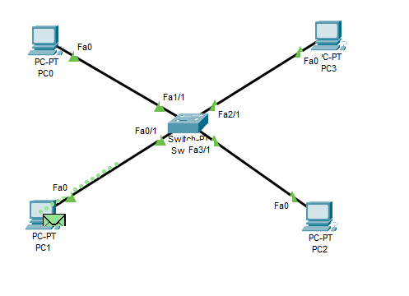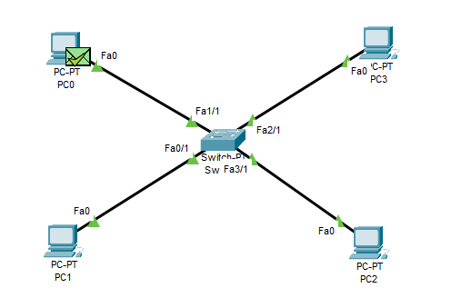

**PC 0 to PC 3**

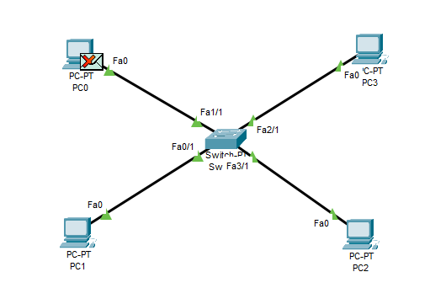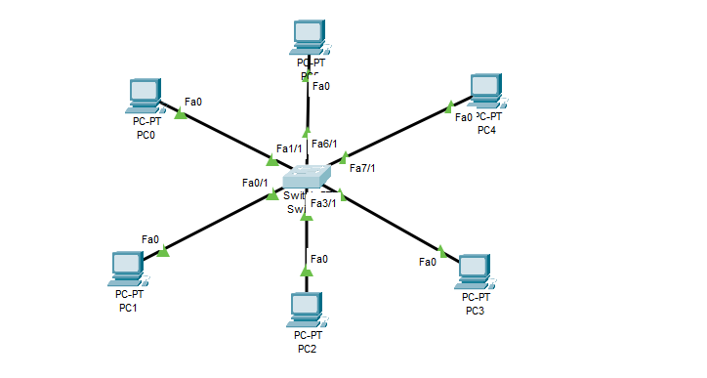

**PC 0 to PC 5**

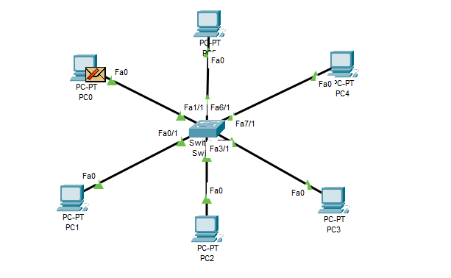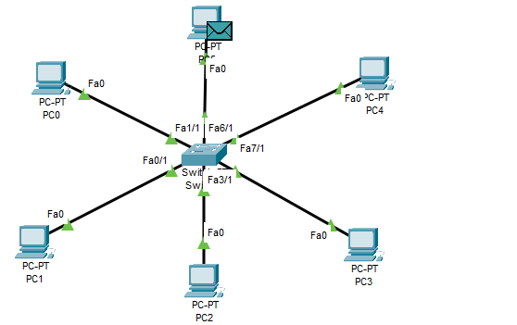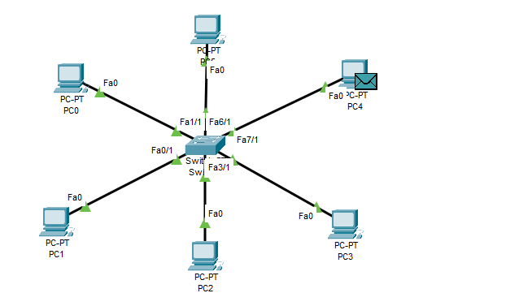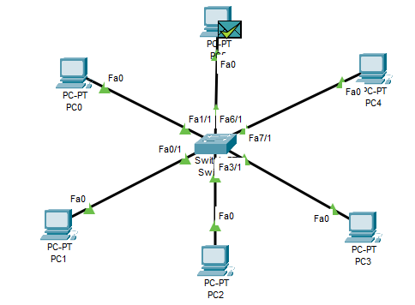

**Network Design**

Fig. VLAN Design

**Screen shots**

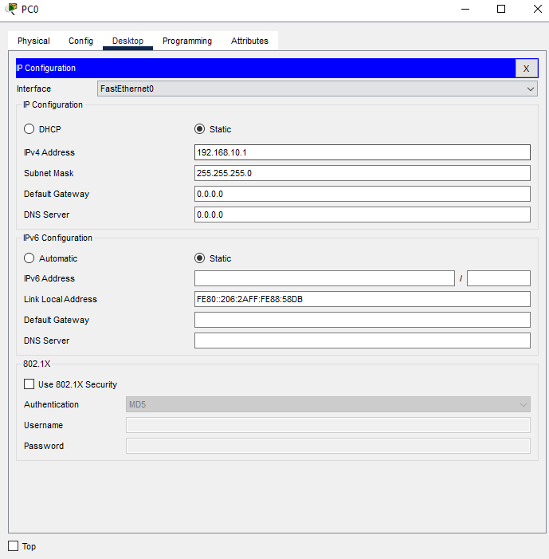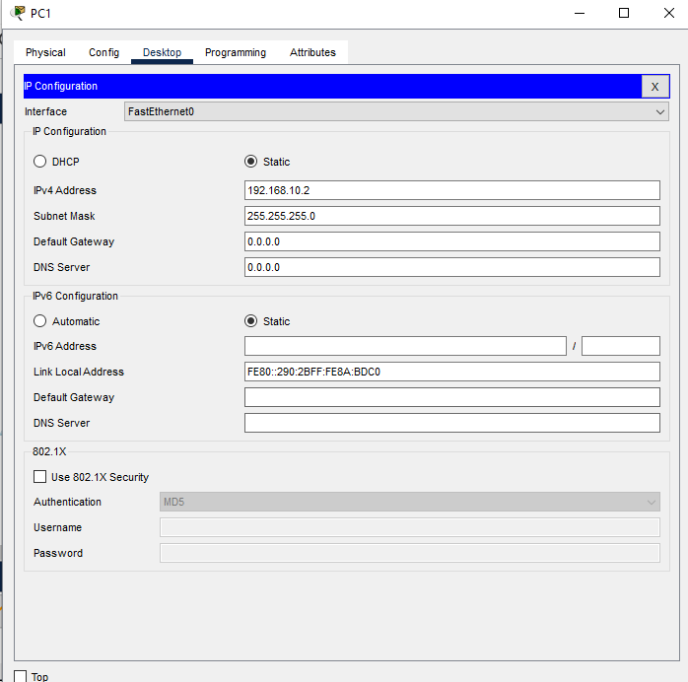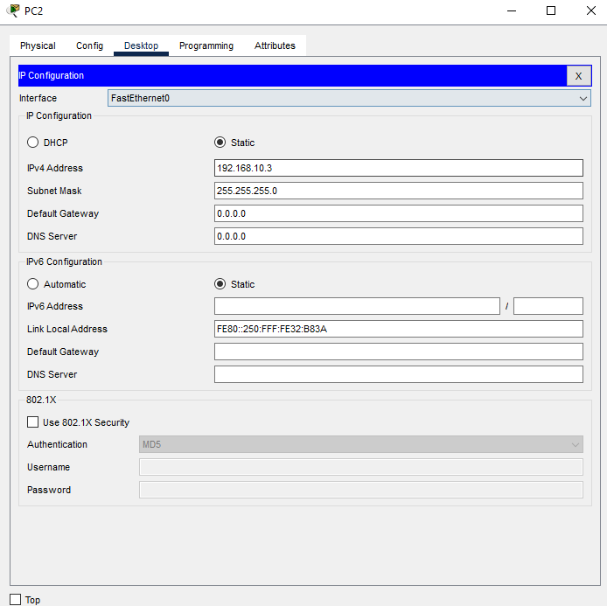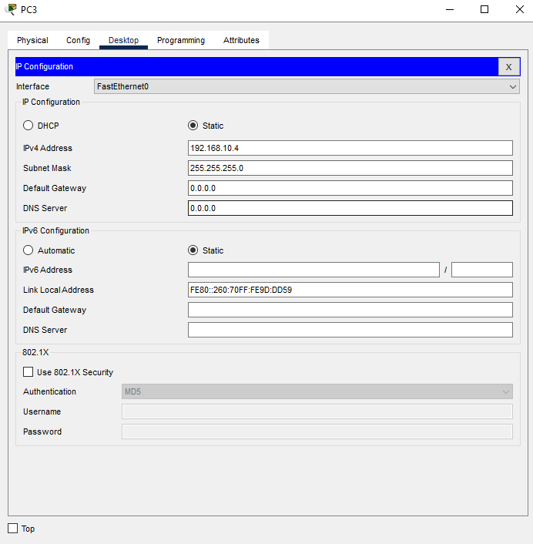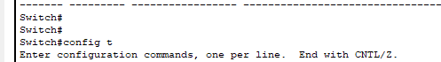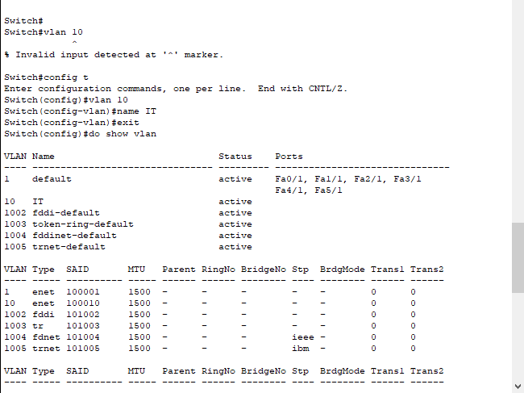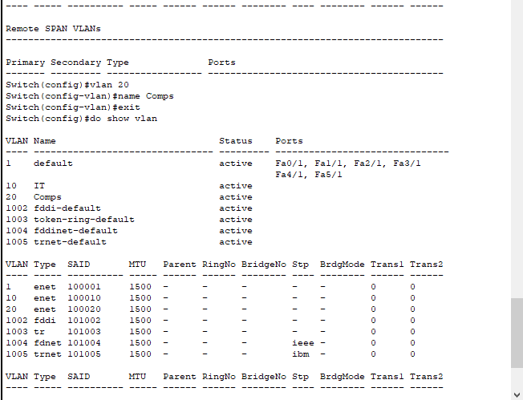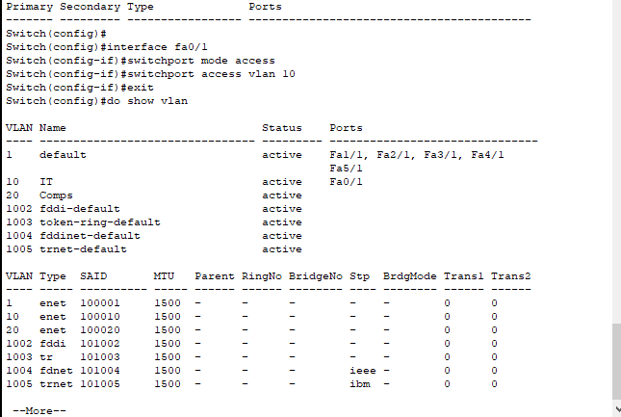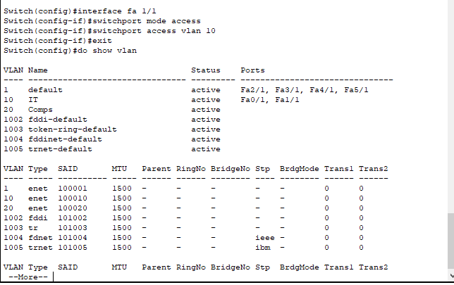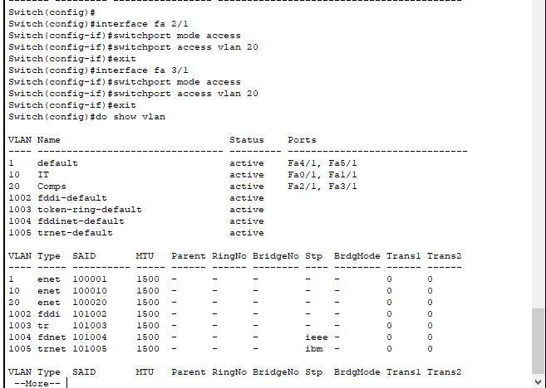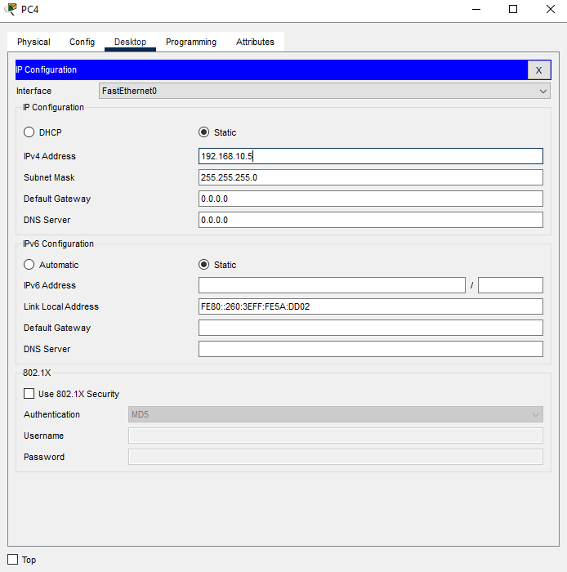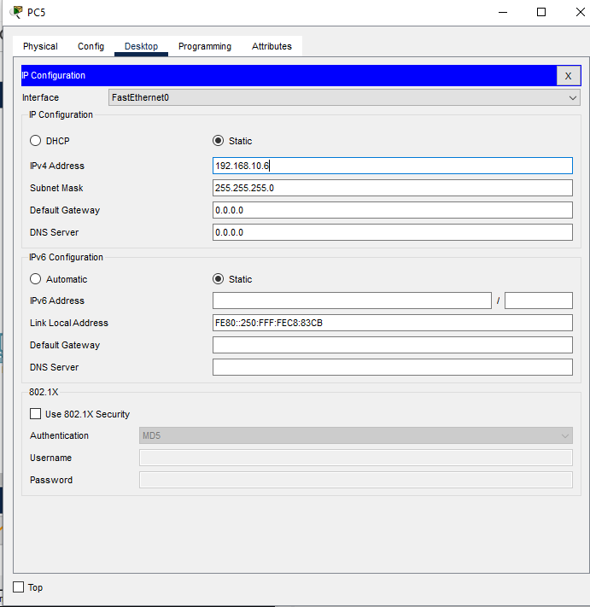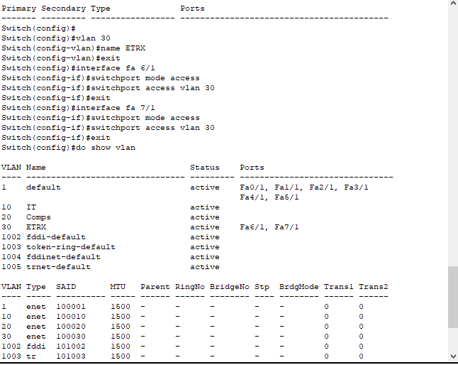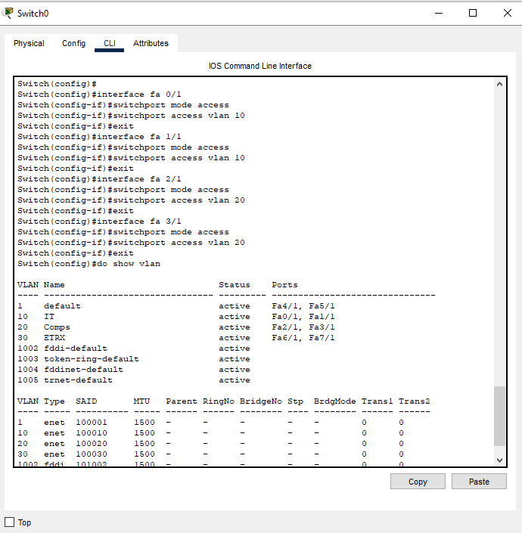

**Post Lab Subjective/Objective type Questions:**

**1.** Describe the concept of Virtual LAN.

A Virtual Local Area Network (VLAN) is a logical subdivision of a physical network that groups together devices on different physical LAN segments, enabling them to communicate as if they were on the same local network. VLANs improve network management by allowing for the segmentation of traffic, providing isolation for different groups, and enhancing security. Each VLAN operates as a separate broadcast domain, meaning broadcasts sent by one device on a VLAN are not seen by devices on another VLAN.

2. Compare LAN with VLAN.

| **Feature** | **LAN** | **VLAN** |
| --- | --- | --- |
| Definition | A physical network that connects devices within a localized area. | A logical network that segments a physical network into multiple broadcast domains. |
| Broadcast Domain | All devices in a LAN are in the same broadcast domain. | Each VLAN acts as a separate broadcast domain. |
| Scalability | Limited by physical constraints and network design. | More scalable; can span multiple switches and geographical locations. |
| Management | Requires changes to physical infrastructure for reconfiguration. | Easier management through logical segmentation without physical changes. |
| Security | Less secure as all devices share the same network. | Enhanced security by isolating traffic between VLANs. |
| Traffic Segregation | No inherent segregation; all traffic is mixed. | Segregates traffic, improving performance and reducing congestion. |

3. State the benefits of implementing VLAN**.**

• **Improved Security**: VLANs isolate sensitive data by restricting access to certain users or devices.

• **Reduced Broadcast Traffic**: By limiting broadcast domains, VLANs minimize unnecessary traffic, leading to better overall performance.

• **Enhanced Network Management**: VLANs allow for easier changes and management of network resources without physical reconfigurations.

• **Flexible Network Design**: VLANs support a more organized network structure, enabling easy segmentation based on organizational needs.

• **Cost Efficiency**: VLANs reduce the need for additional hardware, such as routers, to separate traffic, lowering overall network costs.

**CONCLUSION:** Building and configuring VLANs in Cisco Packet Tracer enhances network management, security, and performance through logical segmentation and isolation.

**Date: _____________ Signature of faculty in-charge**